Operational Research: Tutorial 3
  - Linear Programming 2

Exercises
- Solve the LP using the Problem-Based approach in Pyomo
maximise $12x + 18y$
subject to:
$$2x + 4y ≤ 55 \\ 2x+y≤25 \\ x,y≥0$$
  - Let $x$ and $y$ be restricted to integer values, solve the Integer Linear Program (ILP) using Pyomo
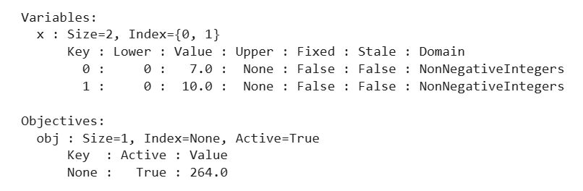
  - Let $x$ be a real value and $y$ restricted to an integer, solve the Mixed-Integer Linear Program (MILP) using Pyomo
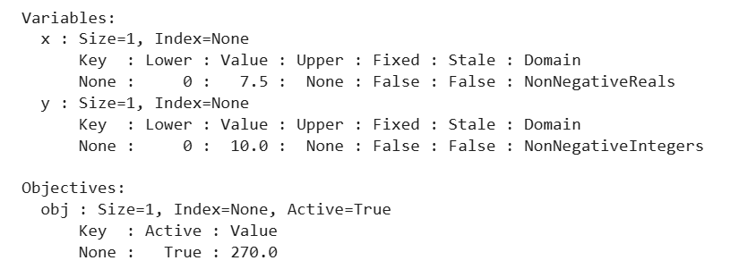
Note: You can graphically plot this to validate your solution.
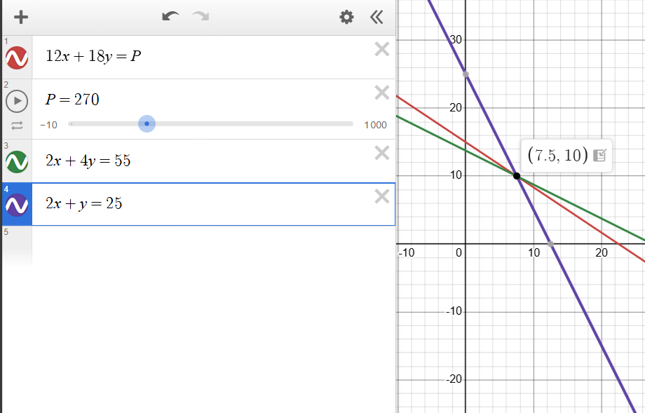

- C&S (Management Consultants) have been employed to help the Icki-Toffee Company to develop a popular, economical but more health-conscious selection of candies to add to their scrumptious range of toffees. There has been much publicity that the Government are so worried about obesity that they plan to introduce a coding system for all food products which will inform the public about products containing foods which may be adding to the problem. There are rumours that the Government aim to strongly promote the concept of fruit as a healthy alternative to sweets, so Icki-Toffee are very keen to introduce fruit, in the form of fillings, soft centres etc into their range. They are determined to ensure that at least one of their selections of candies does not fall into the worst category.

The selection chosen must weigh more than 320g and satisfy certain basic restrictions on fat and calorific content. These are outlined below:

- Total fat content by weight must be less than 45% of the total weight of the selection.
- Calorific value of the selection must be less than 2850 calories.
The quantities of fat and calories in each candy are given in Table 1.
The costs of each candy are given in Table 2.
Table 2 also lists the results of an in-store survey which Icki-Toffee carried out in several of its retail outlets. The popularity number is measured on the scale where 10 is very popular and 0 not popular.
- Formulate a model (using summation notation) given that the aim is to minimise the cost of the selection. Is this a good selection? *

minimise
$$\sum_{i}{C_{i}x_{i}}$$
subject to:
$$\sum_{i}{W_{i}x_{i}≥320} \\ \sum_{i}{K_{i}x_{i}≤2850} \\ \sum_{i}{F_{i}x_{i}≤0.45\sum{W_{i}x_{i}}}$$
and$$x_{i}≥0, ∀i$$
$$x_{i}∈Z, ∀i$$

- Obtain the optimal selection via Pyomo
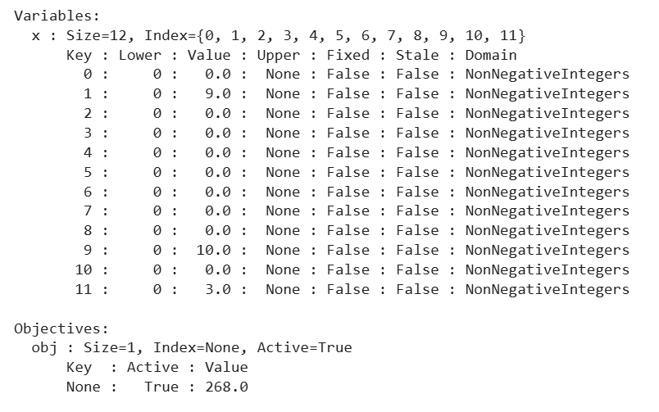

- Obtain the optimal selection given that the aim is to maximise the popularity of the selection via Pyomo, what is the weight of the selection? **

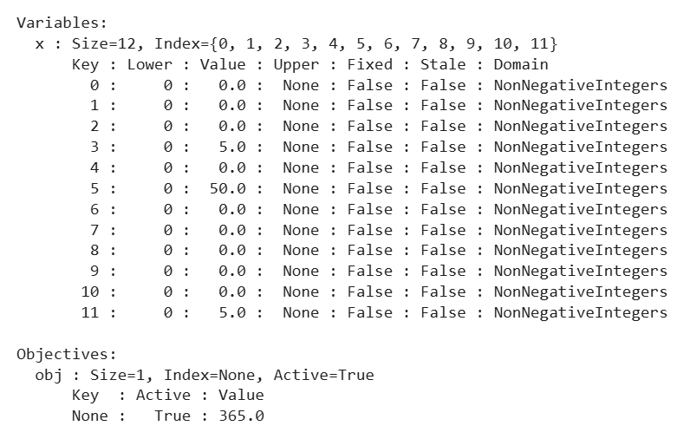

We can now calculate the weight of our selection, above we selected 5 of Coconut Ice, 50 of Lime Sherbet and 5 Grape Bunch.

$$5×12 + 50×10 +5×15 = 60 + 500 + 75 = 635$$

Alternatively we can look at the constraints from the output and see that it is 635:

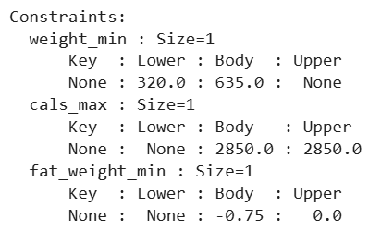

- Comment on whether these are good selections. Would you be happy?

Have a think about this yourself, this isn’t for me to say, but I will comment on it in the next lecture. Is there a flaw in our modelling, what about our objective, is it really maximising popularity?

Candy - $x_{i}$ | Fat (g) - $F_{i}$ | Calories – $K_{i}$ | Weight (g) - $W_{i}$
Buttery butterscotch | 20 | 100 | 24
Caramel softie | 16 | 100 | 22
Orange dream | 10 | 80 | 15
Coconut Ice | 7 | 50 | 12
Lemon sorbet | 6 | 60 | 10
Lime sherbet | 5 | 40 | 10
Strawberry surprise | 13 | 80 | 14
Raspberry mousse | 15 | 90 | 17
Ginger toffee | 18 | 80 | 20
Rose-water posy | - | 145 | 8
Walnut whirl | 19 | 120 | 20
Grape bunch | - | 120 | 15
Table 1: Table to show content information about each candy

Candy - $x_{i}$ | Cost - $C_{i}$ | Popularity - $P_{i}$
Buttery butterscotch | 12 | 10
Caramel softie | 12 | 10
Orange dream | 12 | 8
Coconut Ice | 15 | 9
Lemon sorbet | 13 | 5
Lime sherbet | 13 | 6
Strawberry surprise | 16 | 7
Raspberry mousse | 16 | 8
Ginger toffee | 15 | 10
Rose-water posy | 10 | 3
Walnut whirl | 18 | 8
Grape bunch | 20 | 4
Table 2: Cost and popularity data.

